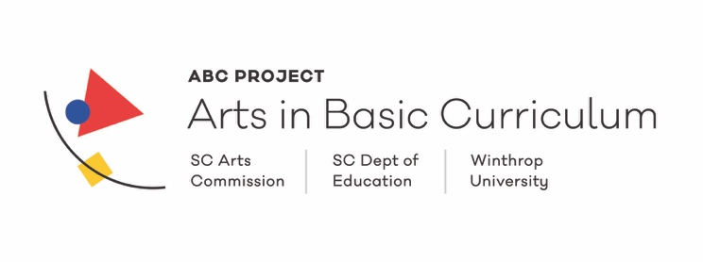
Updated CLIA Lesson Format 2018
Lesson Writer | Write your name.
School  Grade Level | Write the school and grade level at which the lesson will be taught.
Lesson Title and Arts Area | Write a descriptive lesson title. Select from Creative Writing, Dance, Design, Media Arts, Music, Theatre, or Visual Arts.
Statement about the writer, Long-Range Plans, and Lesson Development | Include a very brief bio statement about the lesson writer.  Write a statement about where this instruction belongs in your long-range plan. Write a description of what learning occurred up to this lesson and what learning will occur after this lesson.
Unit Description | Describe the content from which this lesson comes from.
Essential Question | Write an open-ended question that covers the lesson’s content and can be answered at the end of the lesson as a result of what the student has learned.
2017 South Carolina College- and Career Ready Standards for VPA Proficiency (2017 South Carolina CCRVPA) | List the alphanumeric label of the Visual and Performing Arts Proficiency Standards Artistic Process, Anchor Standard, and Benchmark and Indicator that will be taught. For example, THEATRE  Artistic Process--Creating  Anchor Standard1: I can create scenes and write scripts using story elements and structure.  Benchmark--T.CR.NL.1 I can identify basic story elements in simple stories, plays and scripts (e.g. plot, character, setting, theme, etc.)  Indicator—I can identify details about the setting of a simple play or script.
Learning Targets | Identify the Learning Targets in terms of what the student can do. These are your instructional objectives.
Criteria for Assessment | Knowledge and skills assessed for the benchmark and indicator(s) selected.
Description of Instruction for the Lesson | List the methods of instruction used during the lesson such as lecture, demonstration, small groups, etc. Example: Demonstrate contour line drawing.
Teacher Procedures | List and number the instructional procedures the teacher will present as a result of the Learning Target.
Student Tasks | List and number what the students will do as a result of the teacher’s instruction.
Materials | Provide list(s) of materials used during the entire lesson.
Resources | Provide list(s) of resources such as, websites, books, art prints, and student work. Include the complete title for all resources including author’s name. Include complete web addresses.
Attachments | Provide list(s) of handouts such as, pamphlets, brochures, and other documents for the students to use.
Curriculum  Connections and Content Area Standard | Provide list(s) of the content area and how it aligns with other Arts areas including Creative Writing, Dance, Design, Media Arts, Music, Theatre, and Visual Arts List other content areas and how they align with the main content area of the lesson. Include standards to be addressed both in other arts disciplines and other content areas.

